Methods name are:

Ancestor--- ancestor

---ancestor-or-self

Descendent--- descendent

Descendent-or-self

Sibling preceding-sibling

Following-sibling

Parent parent

Child child

Syntax:

/axesMethodName::tagname

url used <https://www.hyrtutorials.com/p/add-padding-to-containers.html>

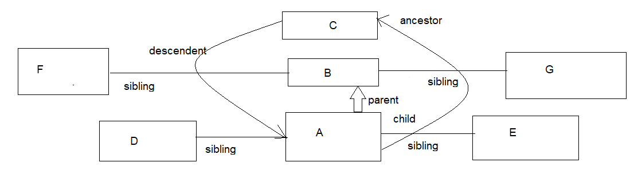

1. following-sibling :

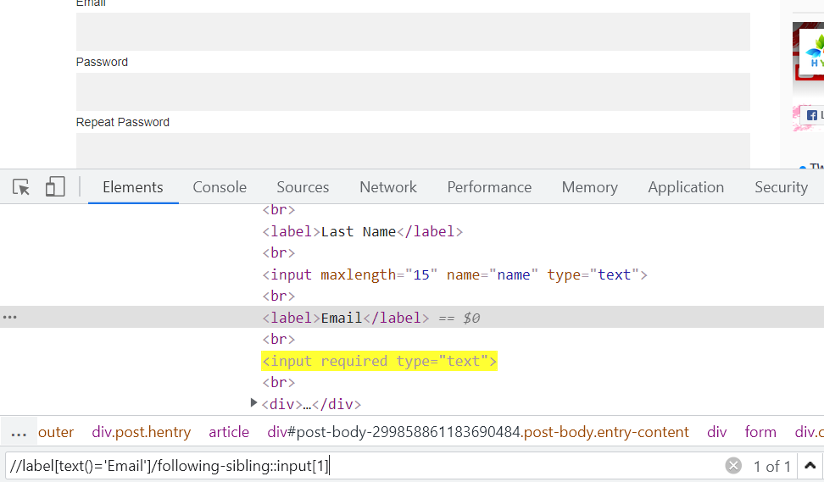

2. parent method:

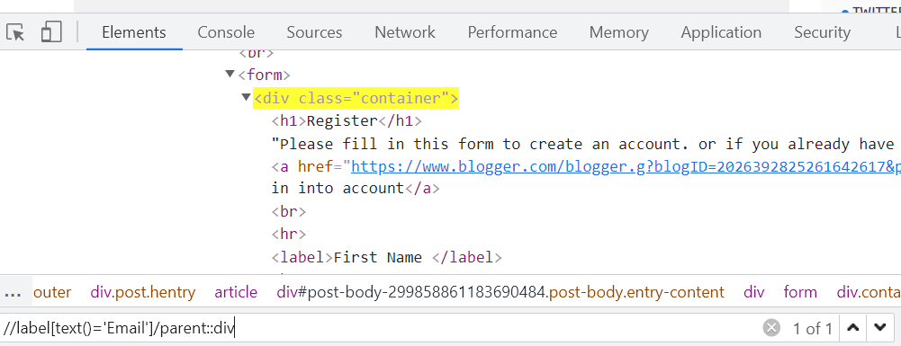 or can be

//label[text()='Email']/following-sibling::input[1]/parent::div

3. child:

//div[@class='container']/child::input[@type='text']

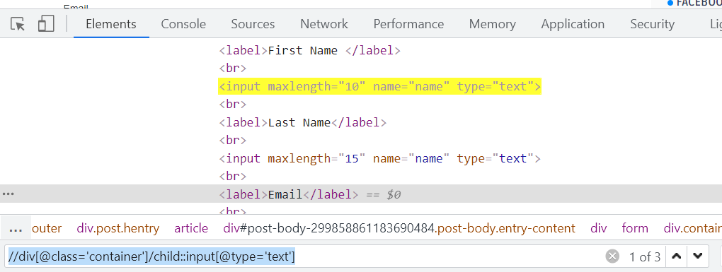

4. preceding-sibling:

//\*[text()='Alice Duval']/preceding-sibling::td/child::input

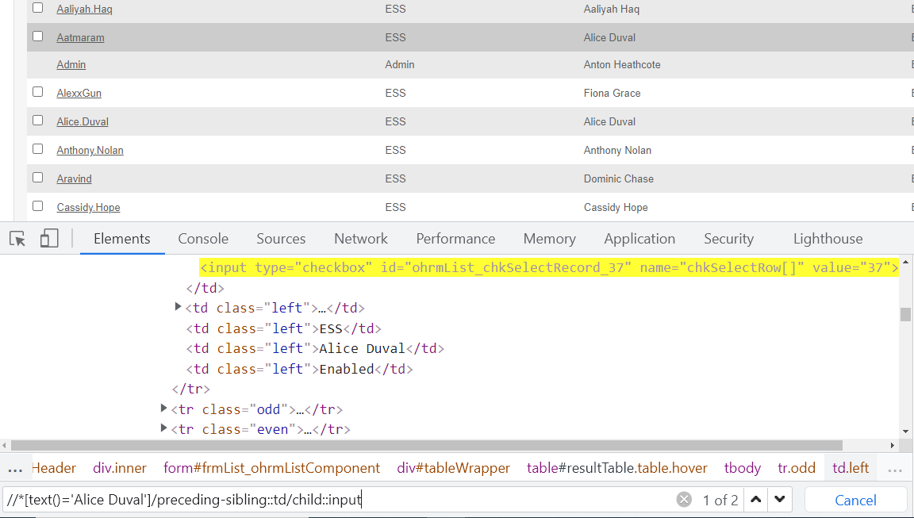

5. Descendant: To locate the grand children:

//div[@class='main section']/descendant::article

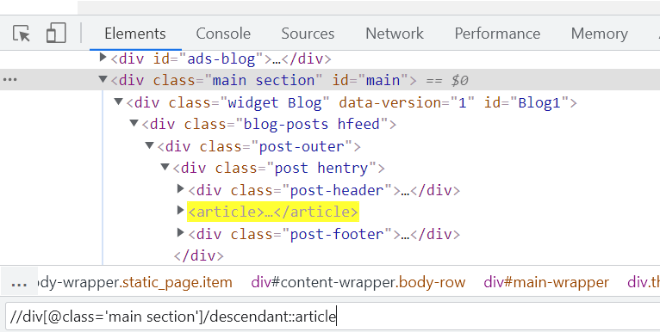

6. Ancestor:

//div[@class='main section']/ancestor::div

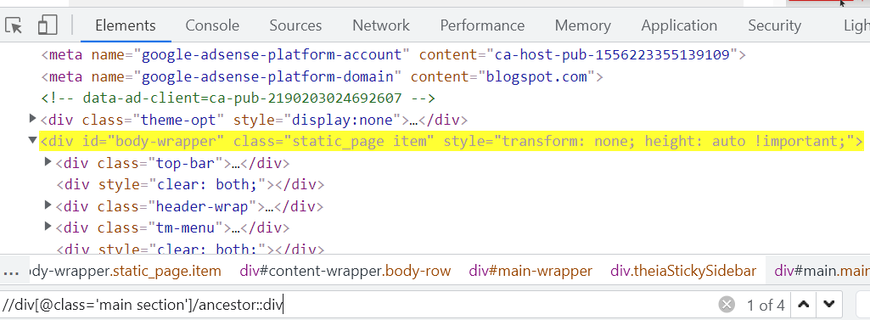

7. ancestor-or-self method:

//div[@class='main section']/ancestor-or-self::div

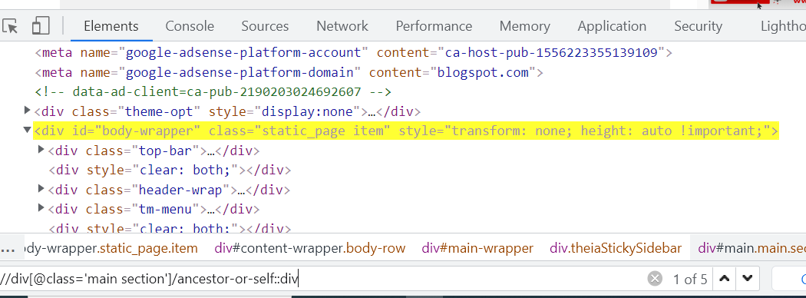

Like wise we have descendent –or-self , following and preceding methods.

CSS Selector:

id

Xpath: //tagname[@id=’value’]

CSS: tagname#value

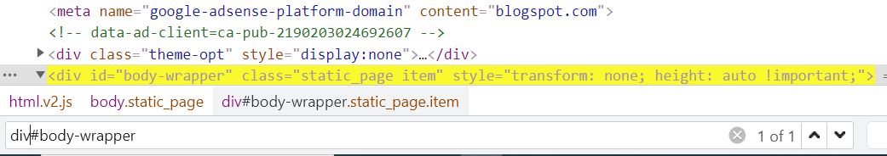

Class:

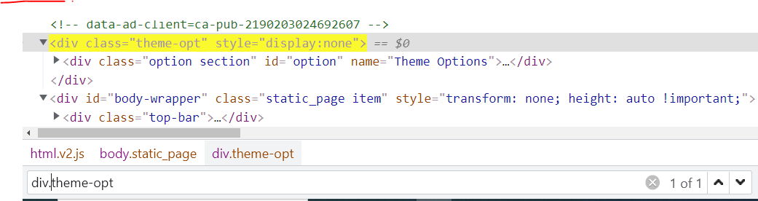

Xpath: //div[@class=’theme-opt]

CSS: div.theme-opt

Parent to child traversing:

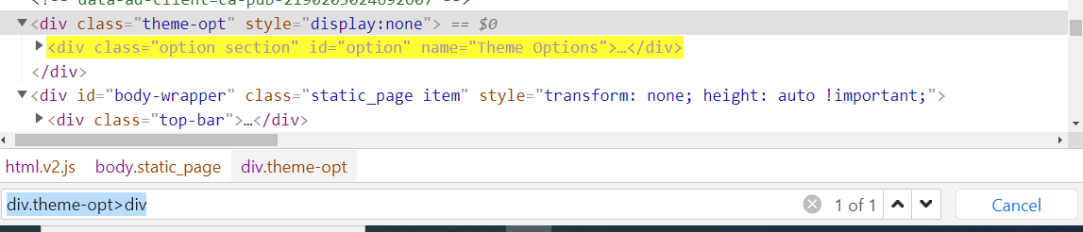

Xpath: //div[@class='theme-opt']//div

CSS: div.theme-opt>div

Some valid CSS:

input[type=checkbox]

or

[type=checkbox]

Starts with in CSS

input[type^=ch]

ends with in CSS

input[type$=box]